Lab 4

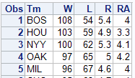

1. Explanatory = Pythagorean Percentage and Response = Winning Percentage
2. 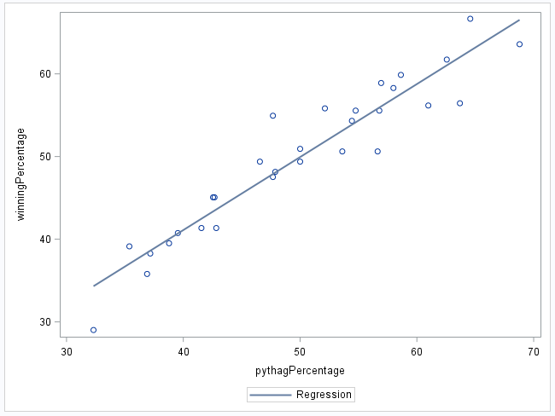
   1. 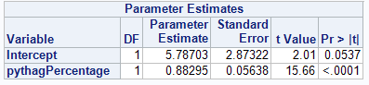
   2. Ŷ = 5.78 + 0.8x
   3. SEA has most positive residual
   4. To calculate the residual, you can do the win percentage minus the predicted value.
   5. LAD has most negative residual
3. 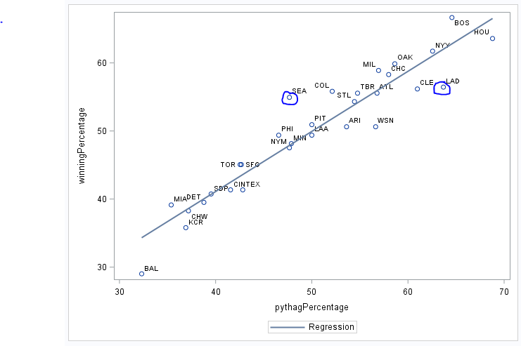
4. The teams with the greater residual means that their correlation between runs scored and runs allowed did not relate to the win percentage. Those above the line had a higher winning percentage based on their runs earned and allowed than many of the other teams.
   1. 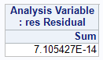
   2. 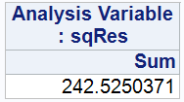
   3. 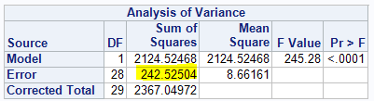
   4. 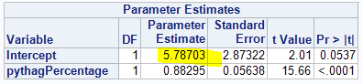
   5. B0 is that value for parameter intercept while B1 is the parameter estimate for the Pythagorean Percentage.
   6. 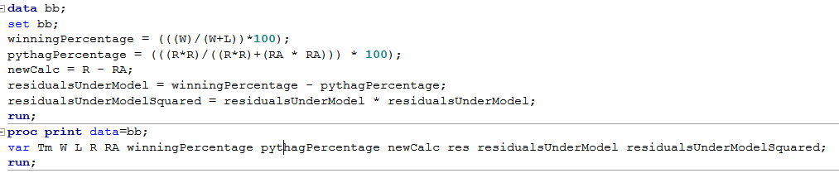
   7. 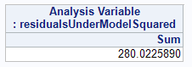
   8. I believe that since the ResSquared Sum found in this is larger meaning it is less accurate and further away from the residual line. This meaning, the distance between the point and the predicted value is greater.
   9. 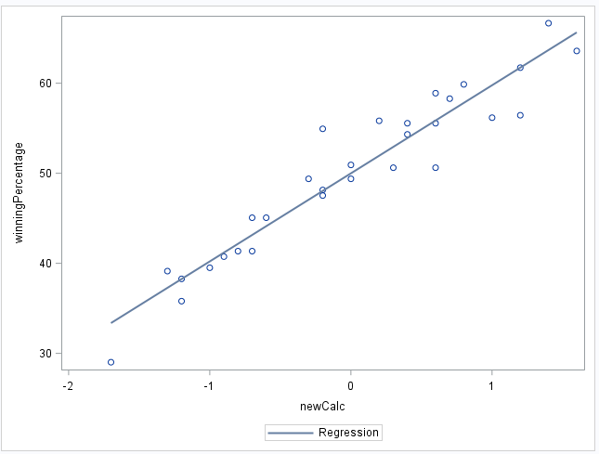
   10. 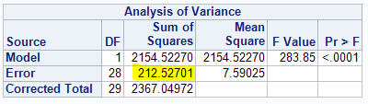In this case, the R – RA will give a closer output because the error for Sum of Squares is lower.
   11. 0.91 (or 91%) is the total variation in win percentage based on the run differential. However, 89.7% is the total variation in win percentage based on the pythag percentage.
5. Test
   1. The intercept is the distance between the predicted value and the actual value. The farther from 0 the intercept is, the closer to prediction the actual value was.
   2. The slope is the increase of win percentage vs the runs allowed. If a team allows more and more runs, that slope should increase based on the results of the other teams.